Return Iterator

rm

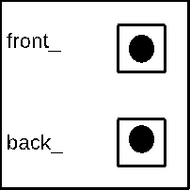



23



15



10



8

